***Introduction***

* The aim is to learn computational modes of thinking, master the art of computational problem solving and make computers do what you want them to do
* To achieve the above we need to:
  + Represent knowledge with data structures
  + We want the computer to infer or find information through iteration and recursion
  + Abstractions will be used to capture elements and then treat them as if they were primitives and reuse them
  + We will organize everything in modules that will allow us to come up with solutions that we can stich together to come up with solutions to problems in interesting ways
  + We will discover that there are various classes of algorithms that can be used for searching or sorting
  + We will learn to deal with the complexity of the algorithms by understanding the costs involved in using various algorithms
* What do computers do?
  + They perform calculations vary fast
  + They remember things
* What kinds of calculations does the computer do?
  + Those build-in to the language
  + Those defined by the programmer
* Even with fast computers we need cleverness, we need algorithmic thinking to take those simple computations and turn them into something more powerful
  + Otherwise using very simple computation it would take you 5.2 days to find something on the web or 30 minutes to make a move in chess based on looking 6 moves ahead
* **Good algorithm design is crucial**
* Despite its speed and size, a computer does have limits:
  + Some problems are still to complex: accurate weather prediction at a local scale, cracking encryption schemes
  + Some problems are fundamentally impossible to compute: predicting whether a piece of code will always halt with an answer for any input (Turing halting program)
* **We can divide knowledge into two types**:

1. Declarative knowledge: statements of fact/truth (i.e. there is a candy taped to the underside of one chair)
2. Imperative knowledge: tells you how to find something it is a recipe, it gives us a series of steps on how to find a solution

* Only the second type of knowledge is important for computing
* **What is a recipe/algorithm**:
  + Sequence of simple steps
  + Flow of control process that specifies when each step is executed
  + A means of determining when to stop

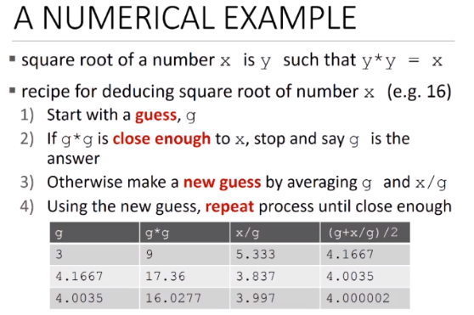

* How do we capture a recipe inside a mechanical process? Historically you had two potions

1. Fixed program: a machine that is designed to do a specific task, i.e. calculator and Alan Turing’s Bombe (enigma)
2. Stored program: a general machine architecture which allows for flexibility in problem solving based on instructions

* Basic Machine Architecture

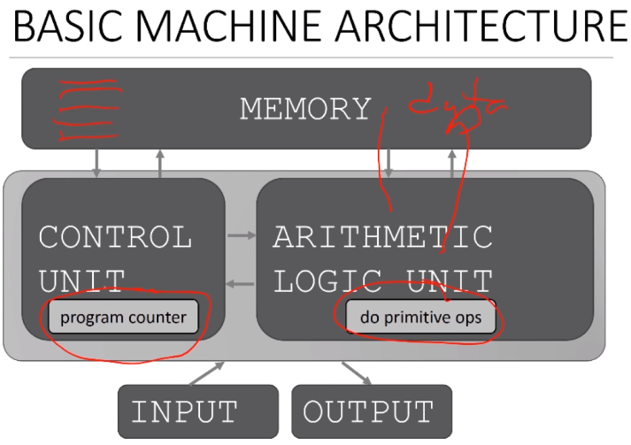

* **Basic Primitives:**
  + Turing showed you can compute anything using 6 primitives (move left, right, scan, read, write, do nothing)
  + Modern programming languages have more convenient set of primitives
  + Abstractions allows us to use existing primitives in order to create new primitives, after you write an algorithm you want to be able to use it as if it came with the machine
* Anything computable in one language is computable in any other programming language (however in some languages it will be easier to do certain things) this property is called Turing Complete
* **Expressions** = more complex but legal combinations of primitives that the programing language will recognize
  + any legal expression is associated with a value; the value is the meaning of the expression
* **Syntax** is the parsing of a sentence to know if it is a legal sentence or not (some combinations of primitives are legal/syntactically valid while others are not)
* **Semantics** or the meaning, it is that to which the expression evaluates to (you can have syntactic validity without static semantic correctness)
  + While in a language such as English syntactically correct expressions can have multiple meanings, in programming languages they can only have one meaning but this meaning may not be what the programmer intended
* Syntactic errors are easily caught by the platform on which you are writing
* Statics semantic errors (things are in the right order but don’t make sense), some languages might catch them as you write others like python after you run the program
* When you have no semantic errors, but the program generates unintended results
  + Program crashes, stops running
  + The program runs forever
  + Program gives different then expected answer and generates incorrect conclusions in further computations
* **Our Goal:**
  + Learn the syntax and semantics of a programming language
  + Learn how to use those elements to translate recipes for solving a problem into a form that the computer can use to do the work for us
  + Learn computational modes of thought to enable us to leverage a suite of methods to solve complex problems

***Python Programs***

* A program = a sequence of definitions (assigning names to variables or creating procedures that will become new primitives) and commands (instruct interpreter to do something)
* **Objects** = the fundamental primitives that represent data
  + Programs manipulate data objects
  + Every object has a type that defines the kind of things the programs can do to them
  + Objects come either as:
    - Scalars which cannot be subdivided
      * Int: represent integers
      * Float: represent real numbers
      * Bool – represent Boolean values
      * NoneType special and has one value None
    - Non-scalars have internal structure that can be accessed
* Can use type() to see the type of an object
* Casting means changing the type of an object
  + I.e. float(5) casts 5 as a float, int(3.5) cast’s 3.5 as an int which result in 3
* **Expressions** combine objects and operators; an expression has a value which has a type
  + Syntax for a simple expression <object> <operator> <object>; i.e. i+j, i/j, etc
* 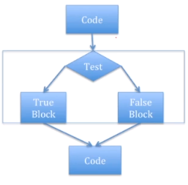We give names to values of expressions so that we can reuse the name and not have to redo the computation every time we want the value
* # is used for comments
* **Branching Programs:**
  + The simplest branching statement is a conditional
    - A test (expression that evaluates to True or False)
    - A block of code to execute if the test is true
    - An optional block of code to execute if the test is False

In python we don’t necessarily need to have the false block

* + 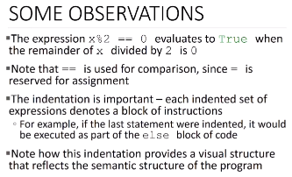A branching example:

x = int (input(‘Enter an integer: ’))

if x%2 == 0:

print(‘’)

print(‘Even’)

else:

print(‘’)

print(‘Odd’)

print (‘Done with conditional’)

* Elif can be used to evaluate multiple things in order

if x<y and x<z:

print (‘x is least’)

elif y<z:

print (‘y‎ is least’)

else: print (‘z is least’)

* Branching programs allow us to make choices and do different things
* But still the case that at most, each statement gets executed once
* So maximum time to run the program depends only on the length of the program
* These programs run in constant time

***Python Basics***

* Operations on strings:
  + Concatenation: ‘ab’+’cd’ -> abcd
  + Successive Concatenatio: 3 * ‘eric’ -> ericericeric
  + Find out length: len(‘eric’) -> 4
  + Indexing: ‘eric’ [1] -> r
  + Slicing: ‘eric’ [1:3] -> ri
* If you use negative numbers when referring to indices you are counting backwards
* In python when you ask for an input the machine will automatically evaluate what you type as a string; thus if you want a number you need to cast the input
* Integrated Development Environment (**IDE**) = text editors for scripting, it allows you to do things that you can run multiple times and also allows for multiple commands (i.e. Anaconda)
  + Comes with:
    - Text editor – use to enter, edit and save your programs
    - Shell – place in which to interact with and run your programs; standard methods to evaluate your programs from the editor or from stored files
    - Integrated Debugger
* **Using control in loops**
  + Simple branching programs just make choices, but path through code is still linear
  + Sometimes want to reuse parts of the code indeterminate number of times

Imagine you are playing a video game and are lost in the forest. If you keep going right, takes you back to this same screen stuck in a loop. How would I write that as code?

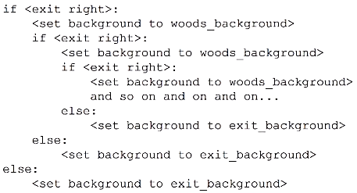

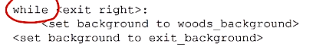As we can see the above if else nest would have to be written an infinite amount of time to work 🡺 we need to use a loop in order to make it work without writing until the end of time

While with counter in the loop and for with range are interchangeable

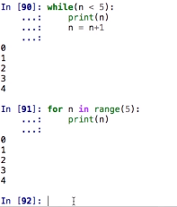

* range(start,stop,step)

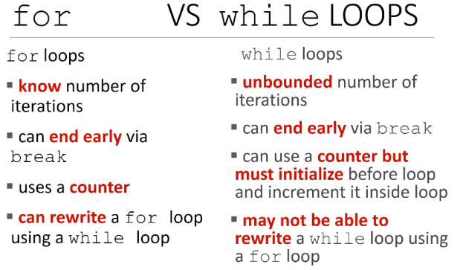

* In python you can iterate over a string using char and a for loop as follows

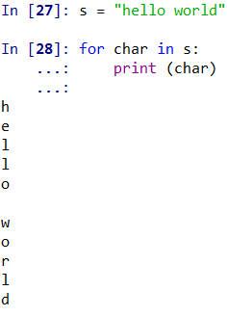

* 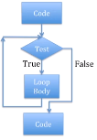**Iteration** = let us extend simple branching algorithms to be able to write programs of arbitrary complexity:
  + Start with a test
  + If evaluates to True, then execute loop body once, and go back to reevaluate the test
  + Repeat until test evaluates to False, after which code following iteration statement is executed

Here we can go through the loop multiple times before we come out

Here is an example:

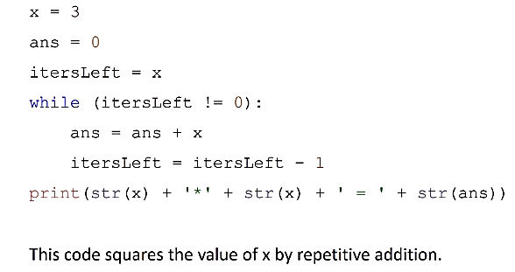

* Branching structures (conditionals) let us jump to different pieces of code based on a test [programs are constant time]
* Looping structures (i.e. while) let us repeat pieces of code until a condition is satisfied [programs now take time that depends on values of variables, as well as length of program]
* **Classes of Algorithms:**
  + Iterative algorithms allow us to do more complex things than simple arithmetic
  + We can repeat a sequence of steps multiple time based on some decision; leads to new classes of algorithms
  + One useful example are “guess and check” methods
    - Remember our declarative definition of square root of x
    - If we could guess possible values for square root (call it g), then can use definition to check if g*g = x
    - We just need a good way to generate guesses
      * we need a systematic way to make guesses for the possible answer, check them, and keep doing that in an iterative algorithm until we find a good solution
* Useful to think about a **decrementing function:**
  + Maps set of program variable into an integer
  + When loop is entered, value is non-negative
  + When value is <= 0 loop terminates
  + Value is decreased every time through loop
* Suppose we didn’t initialize the variable?
  + Liky get a NameError, or worse use an expected value to initiate the computation
* Suppose we don’t change the variable inside the loop?
  + Will end up in an infinite loop, never reaching the terminating condition
* **Exhaustive enumeration:**
  + Guess and check methods can world on problems with finite number of possibilities
  + Exhaustive enumeration is a good way to generate guesses in an organized manner

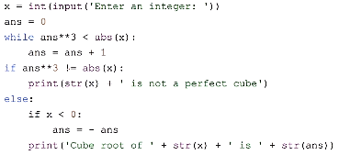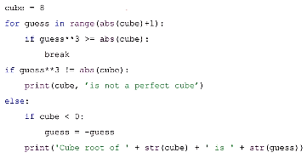

***Simple Programs***

* Approximate Solutions
  + Good enough solution
  + Start with a guess and increment by some small value
  + |guess^3 - cube| <= epsilon; for some small epsilon
  + Decreasing increment size -> slower program
  + Increasing epsilon -> less accurate

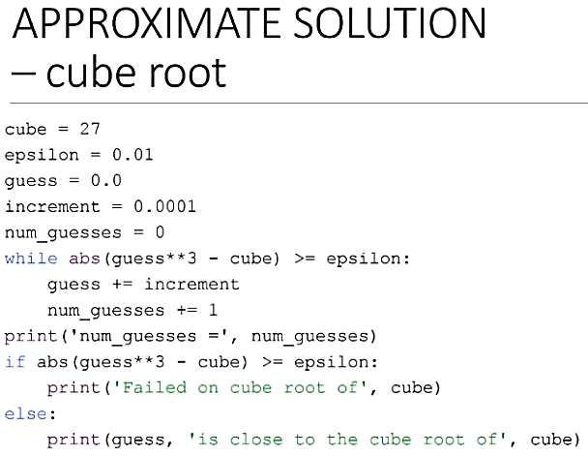

With this test the loop works as long as it is bigger than epsilon 🡺 if the increment is to big, we may always be bigger than epsilon

Hence, we need to add to the while loop one more condition: and guess <=cube so that if we go above the cube value with our guess we stop the process

* **Bisection Search**
  + we know that the square root of x lies between 1 and x, from mathematics
  + rather than exhaustively trying things starting at 1, suppose instead we pick a number in the middle of this range

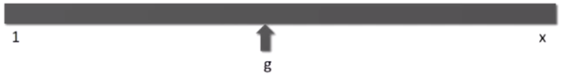

* + then we ask if the guess was to big or to small
  + if g**2 > x, then we know g is too but now search

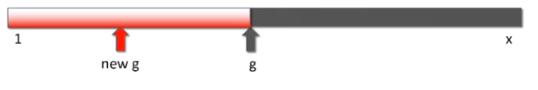

* + now is g**2 < x, then we know it is too small, so now we search

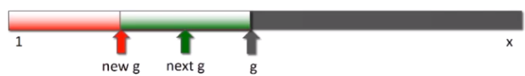

* + Bellow we have an example of computing square root with bisection search

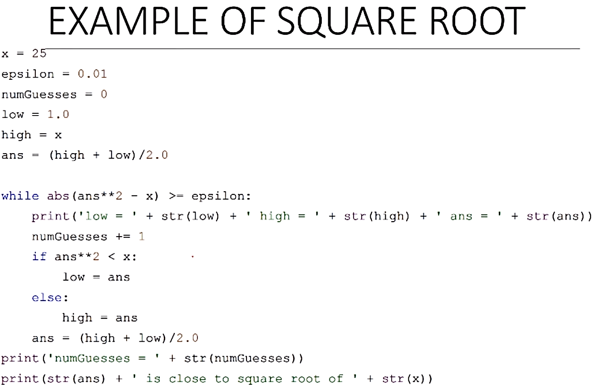

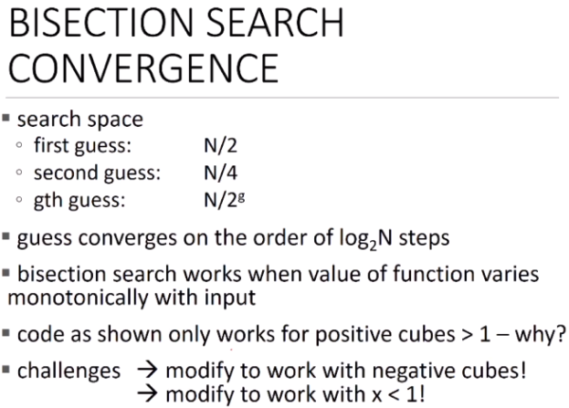

* Given the way floats are calculated we should not compare them with the == sign. Instead we should use abs(x-y) < some small number

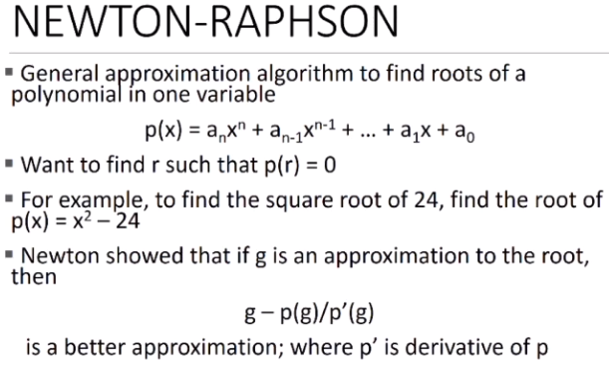

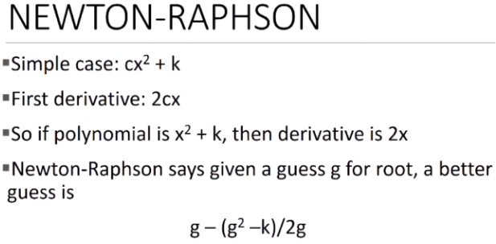

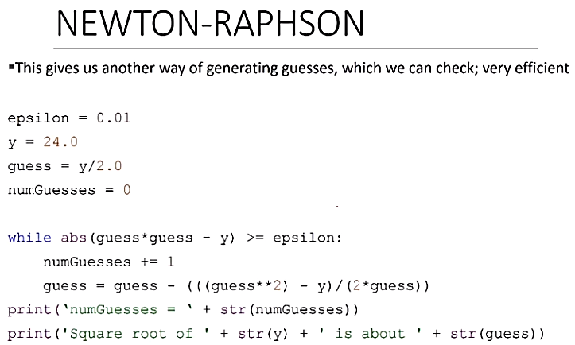

***Functions***

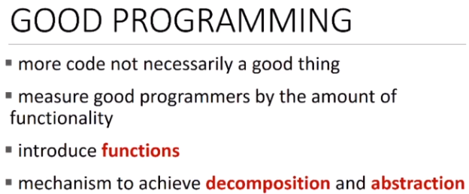

Functions give us ways to encapsulate pieces of computation

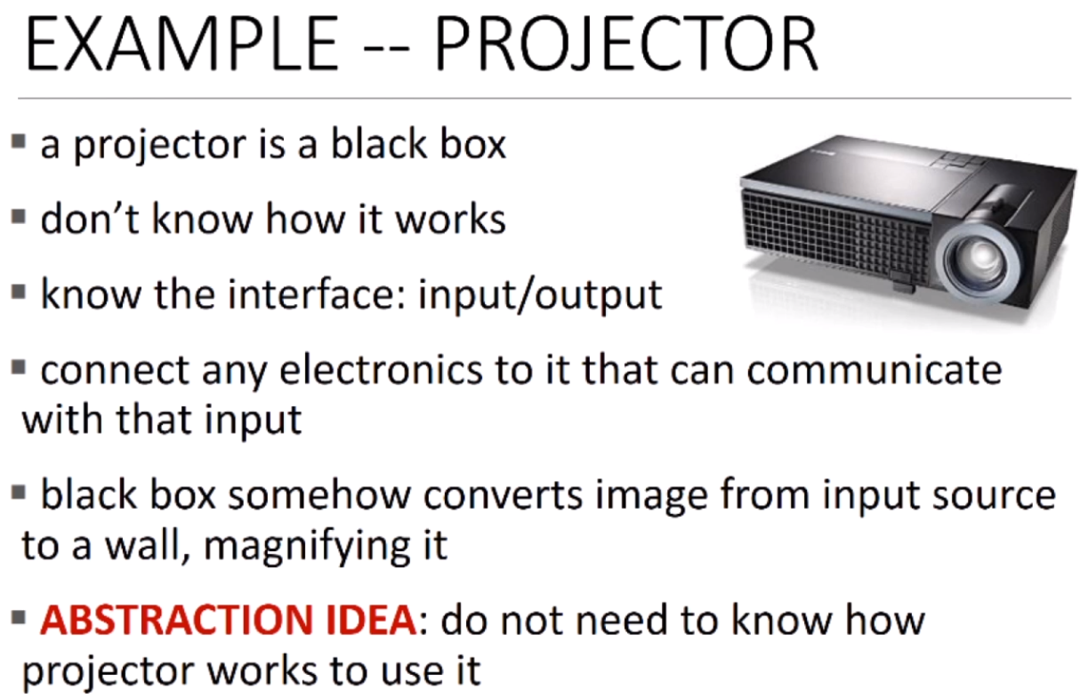

Abstraction once I have built something, I do not need to know how it is built in order to operate it

i.e. if you give me appropriate inputs, I will behave in appropriate way

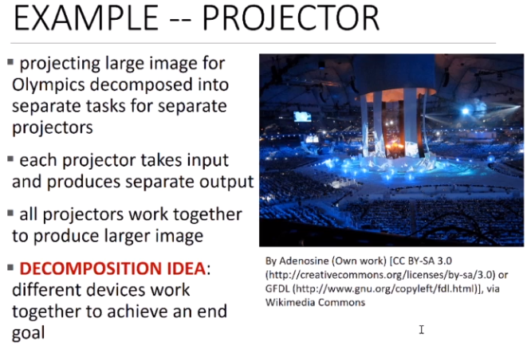

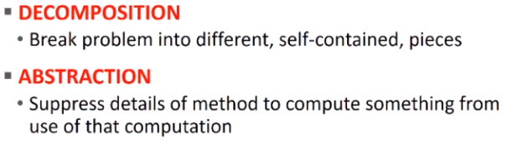

* Decomposition in programing is about dividing code into modules:
  + It’s self-contained
  + Used to break up code
  + Intended to be reusable
  + Keep code organized
  + Keep code coherent

Decomposition can be achieved through functions or classes

Decomposition creates structure

* Abstraction in programing is building a black box:
  + Cannot see details
  + Do not need to see details
  + Do not want to see details
  + Hide tedious coding details

Achieve abstraction with function specifications or docstrings

Abstractions suppress details

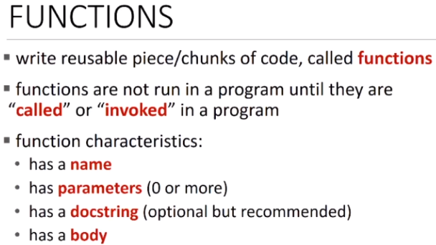

Here is how I write a function:

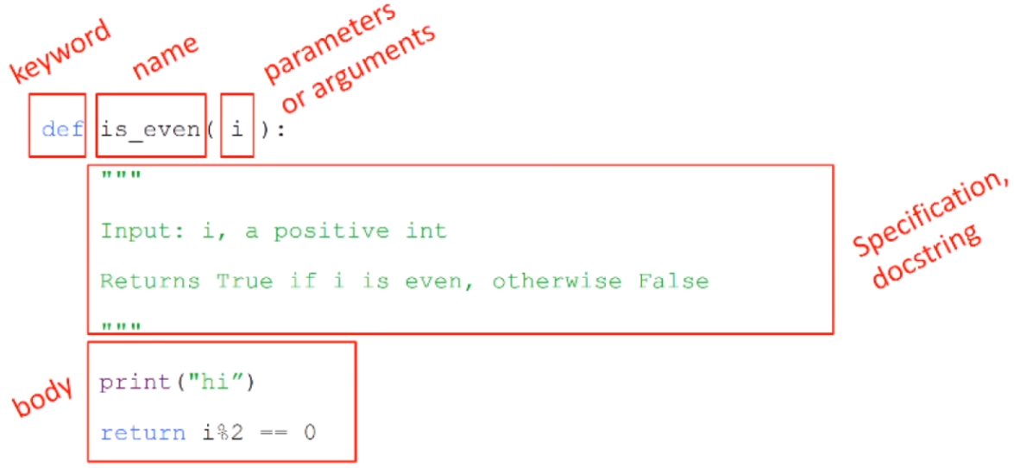

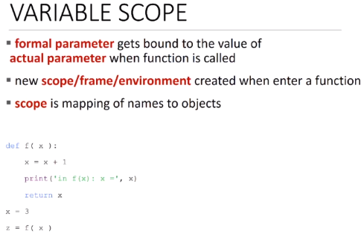

* If we have a function that has no return specified, python will return the value None

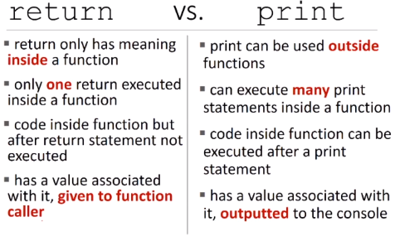

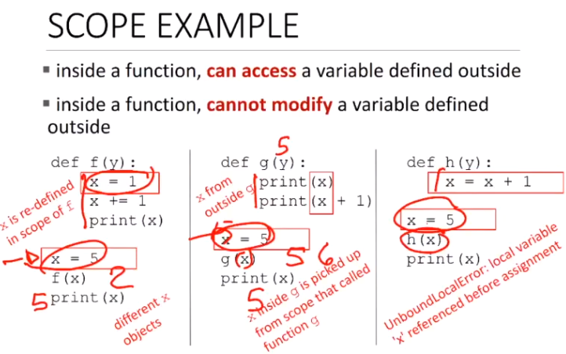

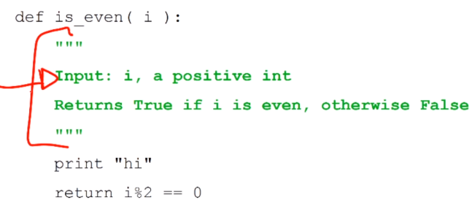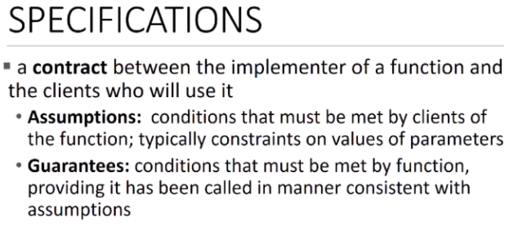

Specifications are entered through a docstring as shown in the small example here:

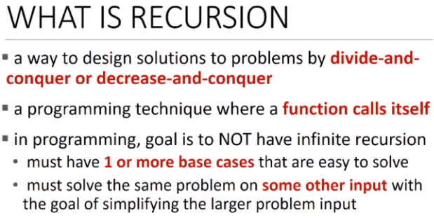

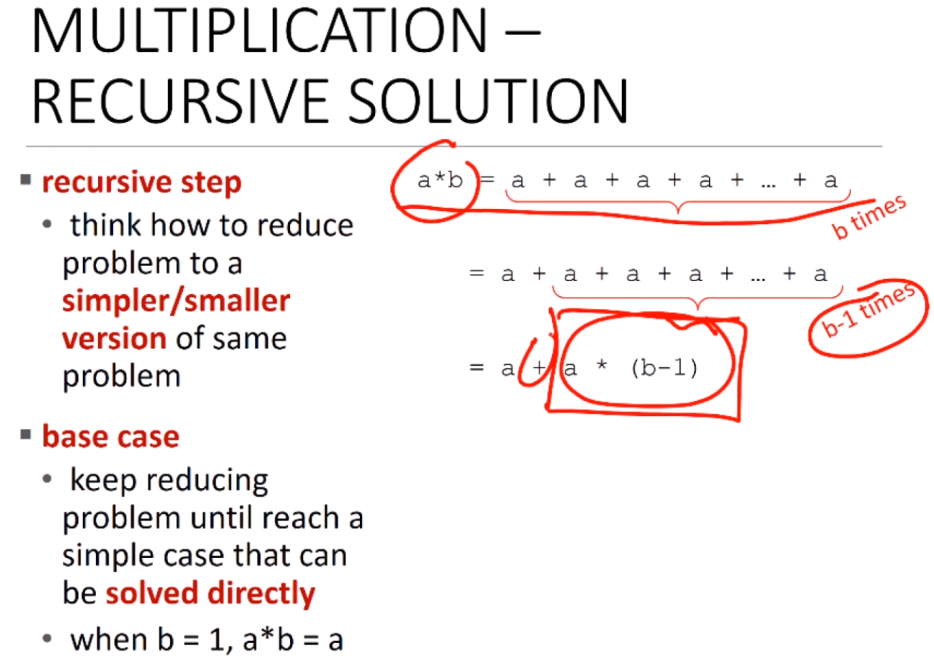

Pattern for generating recursions:

Break it down into a smaller version of the same problem, plus some operations I want to do

Figure out when can I stop breaking it down into smaller versions of the same problem because I know how to compute it directly (In case of the factorial and multiplication it was when n == 1 or b == 1)

Restating the above via a*b = a + a * (b-1) we have reduced the problem to a simpler version of the same problem plus an operation I know how to do.

Now I can continue to say that a*b = a + a + a * (b-2)

This allows me to generate a recursive implementation of multiplication

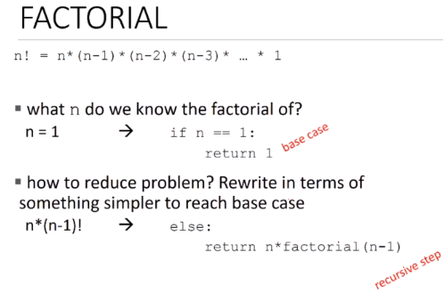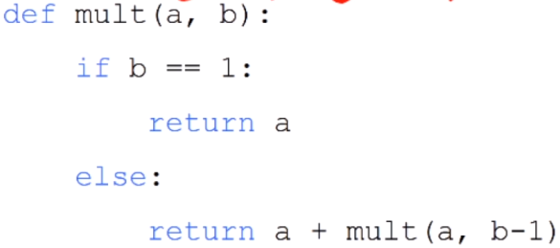

Recursive

Step

Base case

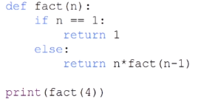

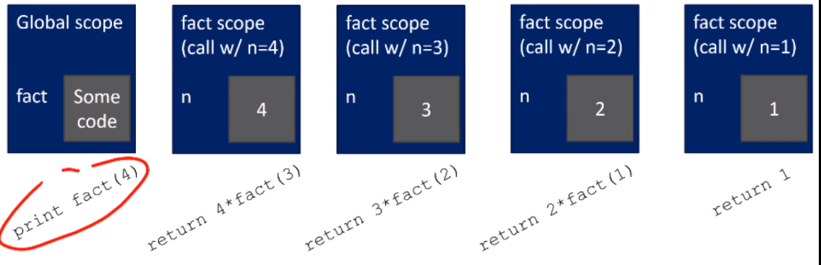

Print (24)

return 4 * 6

return 3 * 2

return 2 * 1

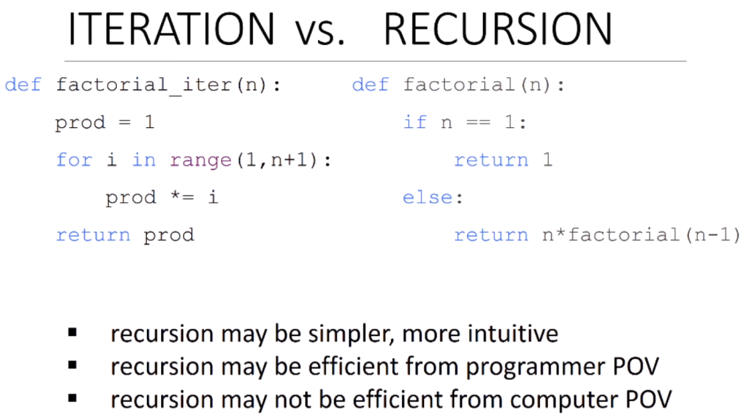

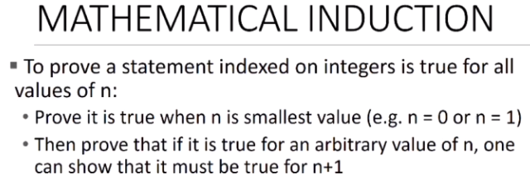

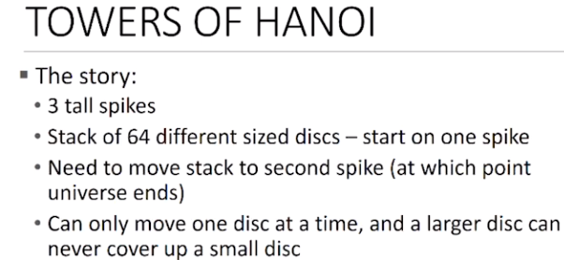

Recursive Solution:

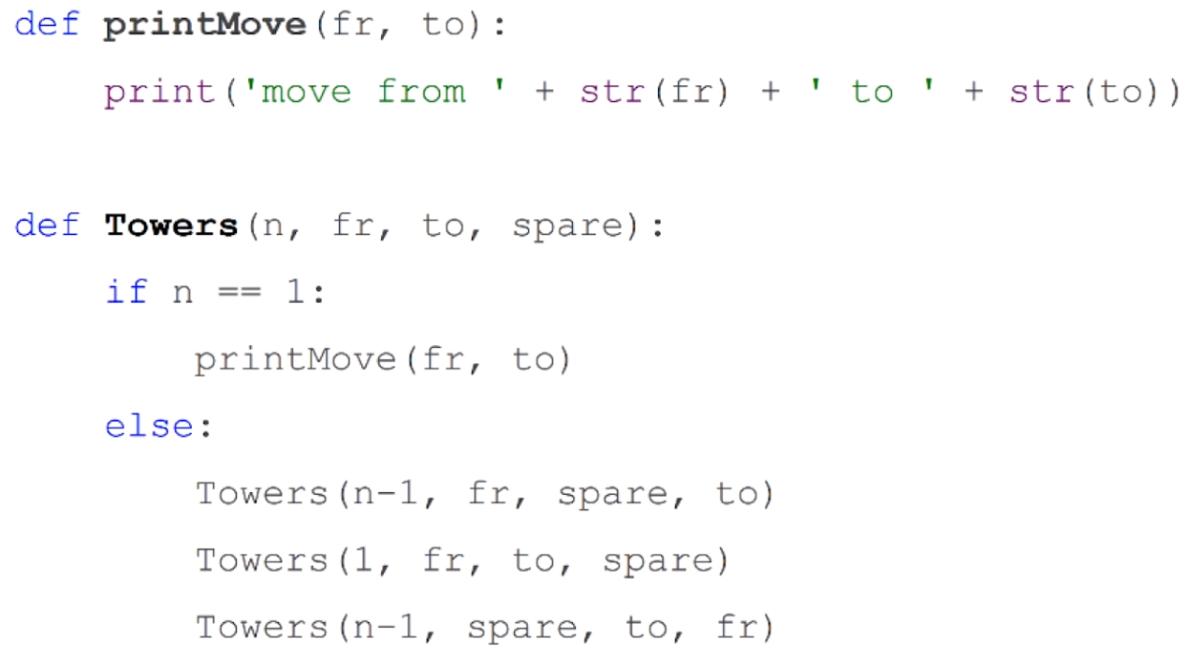

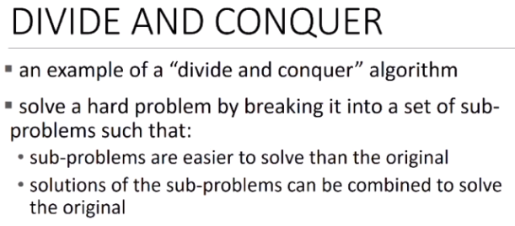

***Structured Types***

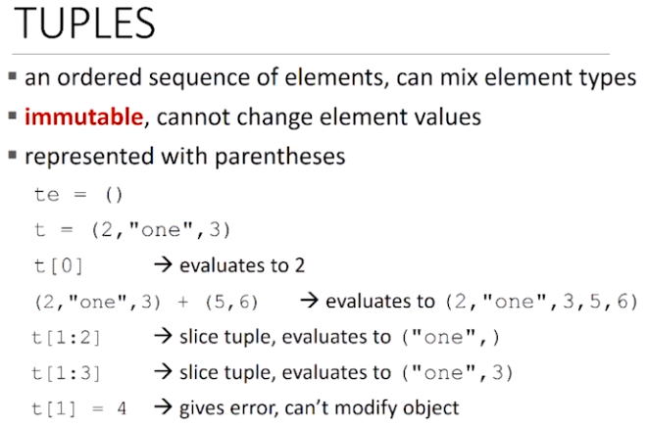

With tuples we get an extra comma. This is doe to let us know that this is a tuple and not just an expression that’s going to reduce to a single element

-> this is an empty tuple; () designate that te is a tuple

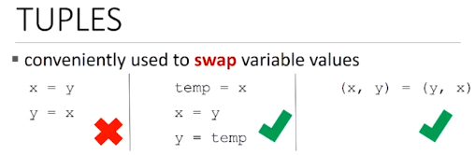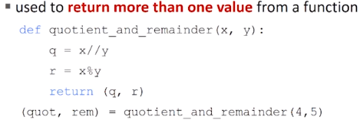

In the function we compute both the quotient and the remainder. As return only returns one variable we need a way to return both. We can use tuples for this

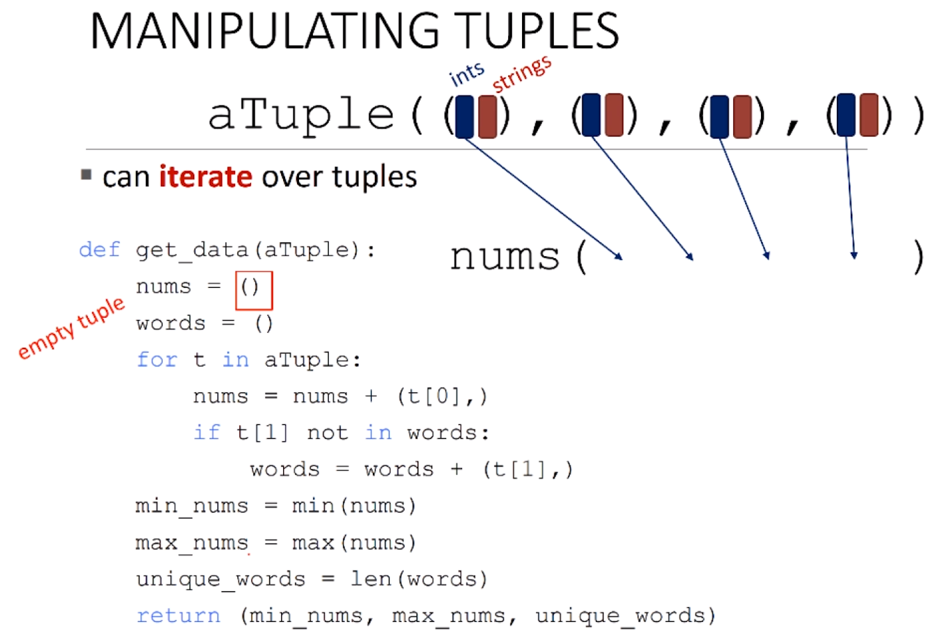

We have a tuple of tuples. The original tuple, aTuple is made out of multiple tuples that contains strings and ints. This functions sorts int with int and string with string in two new separate tuples.

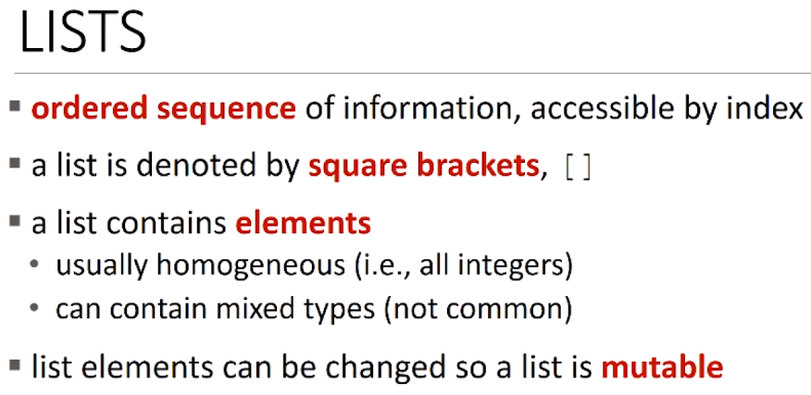

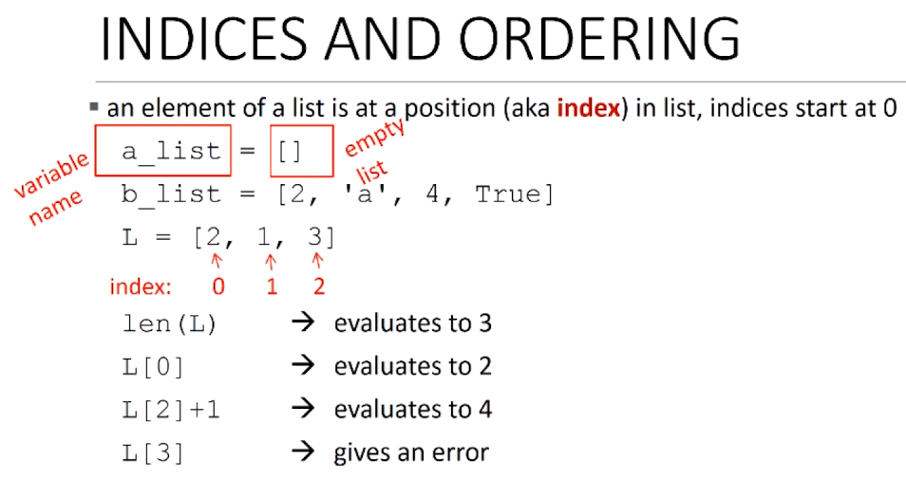

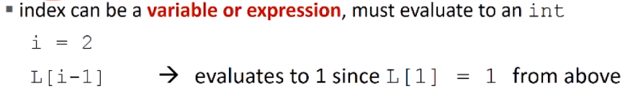

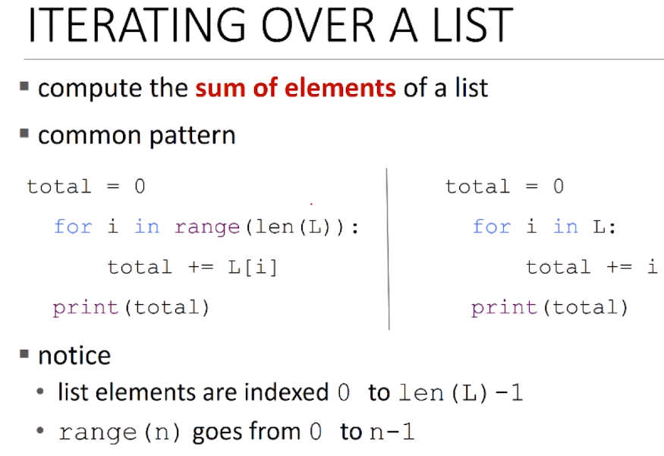

* L = [2,1,3]

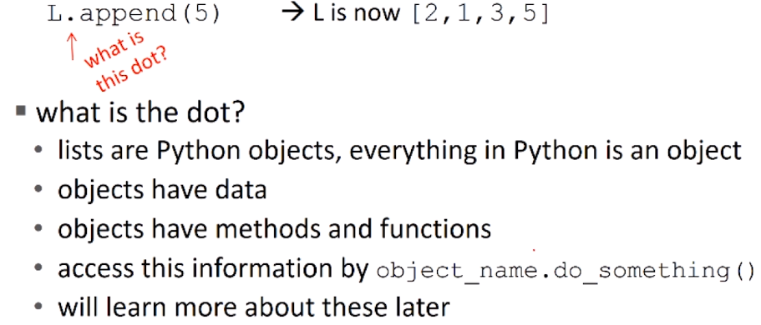

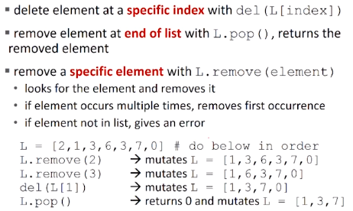

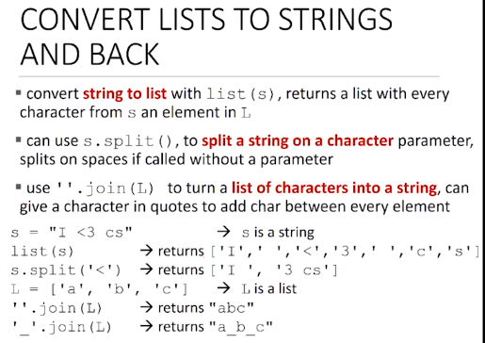

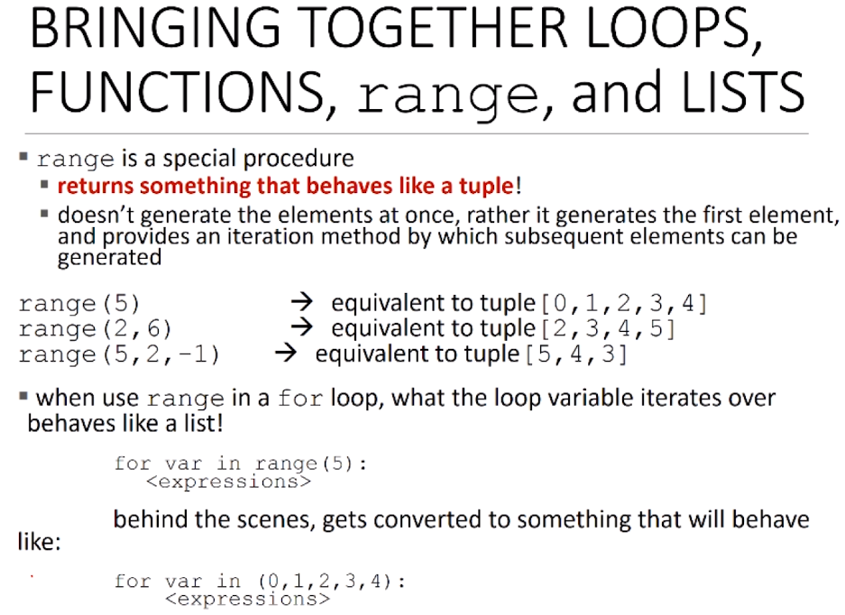

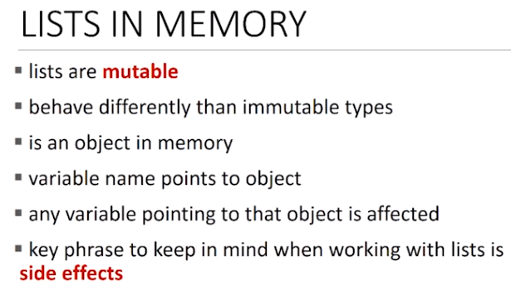

We can have multiple variables pointing to the same list 🡺 if we change a element of the list via one variable it also changes in the other variables

If multiple variables point to the same structure, they are called aliases

* However, if two list variables print out the same thing they are not the same, they must no necessarily be aliases of the same list. 🡺 same print does not result in equality
* I few define a list chill and then say chill = cool these two are aliases of the same list. In order to transfer the values contained in a list to another variable without creating an alias we have to clone the original list variable, in this case cool, as below

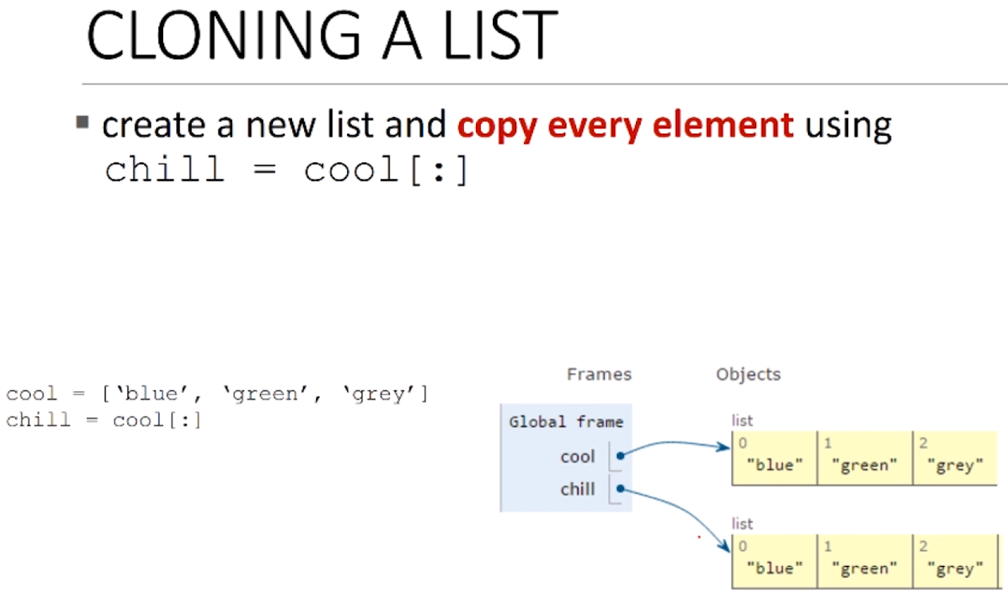

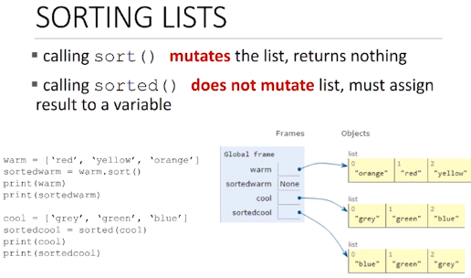

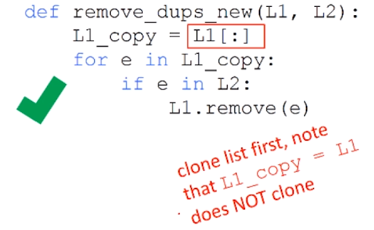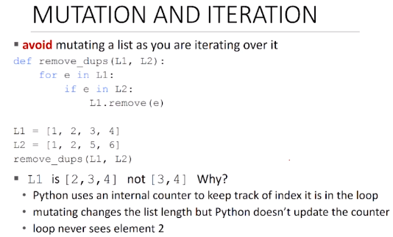

A working version requires a clone of the list ad would we written as below

Higher order programming is when we are using function inside of lists to do things using lists example below

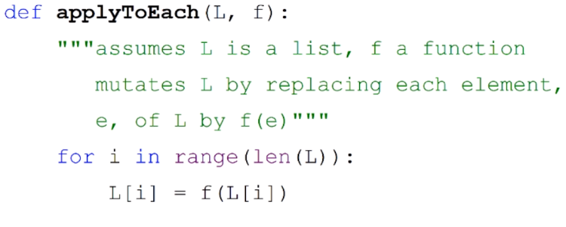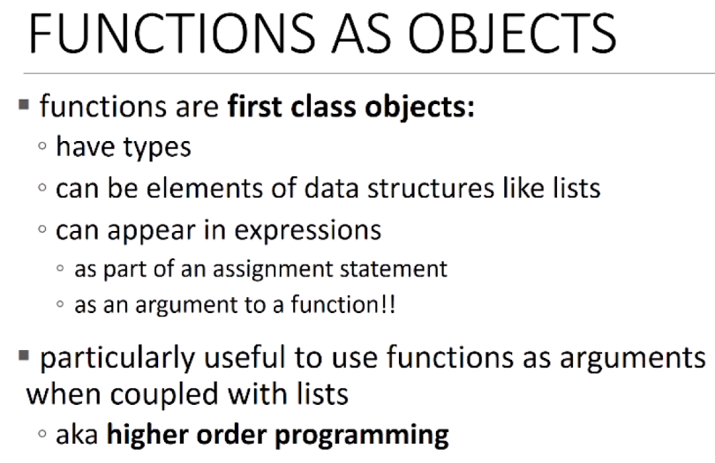

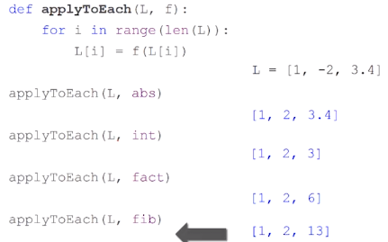

An example of using the above

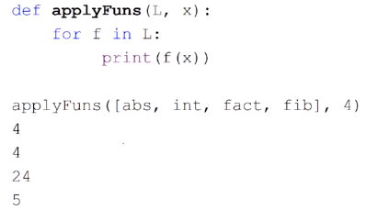

* We could also apply lists of functions to numbers. We use the below where we assume that L is a list of Functions. The function applyFuns loops over the list of functions and for each element in the list prints (f(x))
* We can generalize the above through a higher order procedure (HOP). Python provides this through map

In its simplest form, it takes the function – a function that expects only one argument – it takes a collection, in this case a list of appropriate arguments, and it literally creates a list where it has applied that function to each element in turn.

It returns an inerrable that we need to walk down. And in fact, we can do that with the for loop which will print each one out (see in blue, under print, the results)

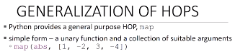

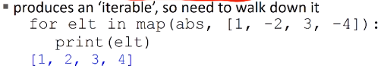

* Map gives me back a structure that is going to act like a list but I must walk it down, iterate over, to get back out.

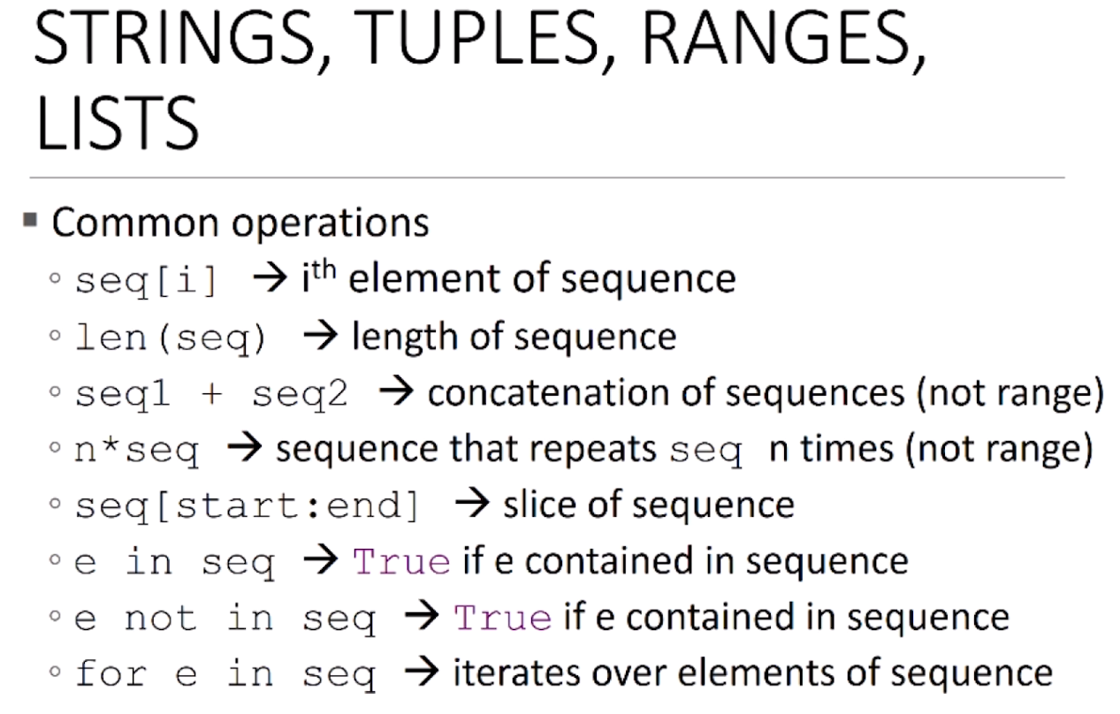 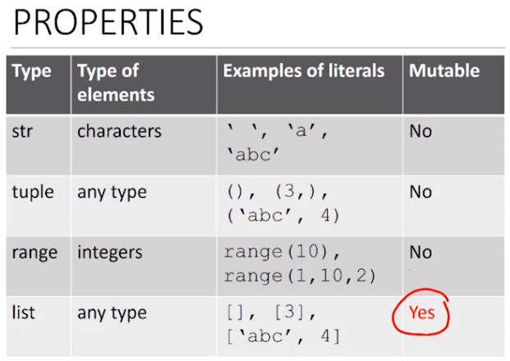

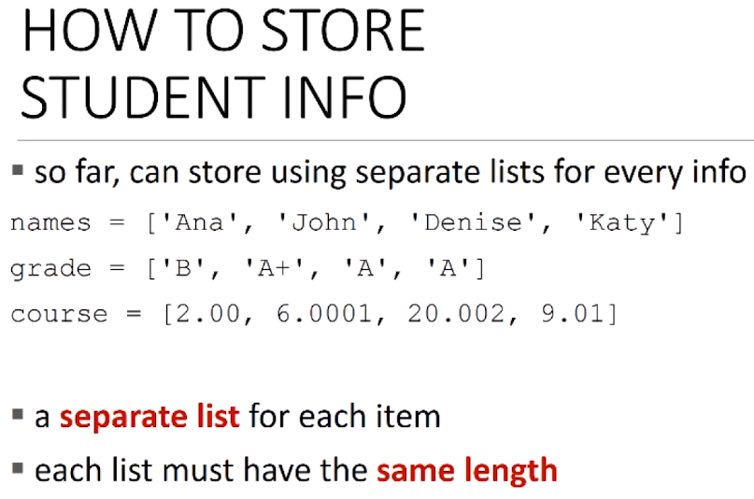

In order to make the correct association I need all of the list to be of the same length, and the elements of each list that are to be associated need to be at the same index.

i.e. *Ana* got grade *B* at course *2.00*, all have index 0

Problem: The association isn’t covered in a common place

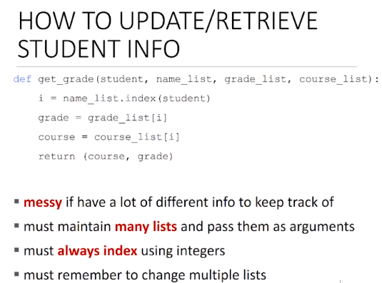

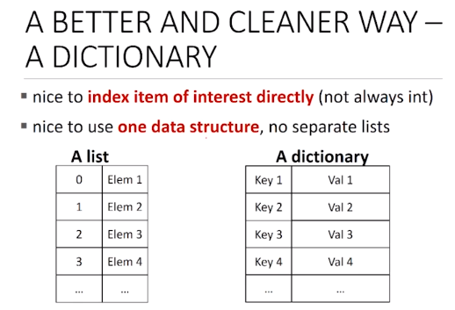

Dictionaries allow us to create a different way of adding and finding things associated to a particular entry structure.

A list has an index and then an element associate with said index.

A dictionary has a key, that is used as a label, and that tell us where to find the element inside of the dictionary

* While dictionaries don’t have a nice linear structure like lists, there wills still be a structure just that this structure will grant us more power in terms of how we retrieve elements out of dictionaries
* A python dictionary stores pairs of data together. A key and a value. The key telling me the thing to look up.

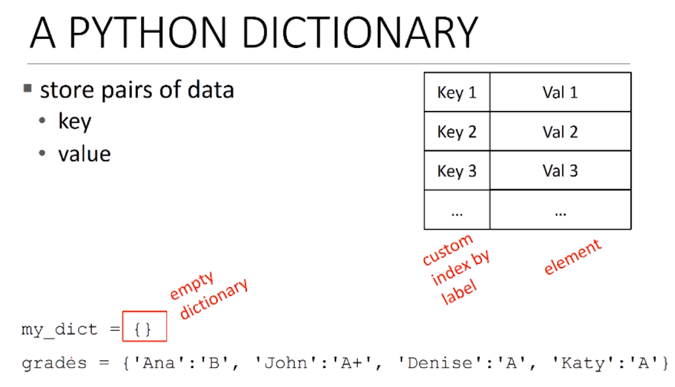

You index in the dictionary by the key element of the entry inside of a dictionary. I.e. Ana, John, Kary

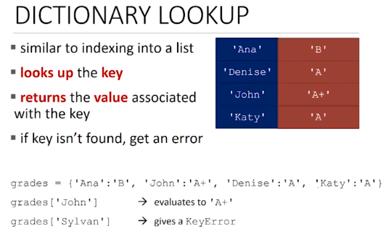

Say I want to retrieve the grade associated with John. Now in a list I would have needed to know what’s the index at which john is stored. I can only index in a list based on an integer.

But with grades as a dictionary, I can say give me back the value associated with that key, i.e. John

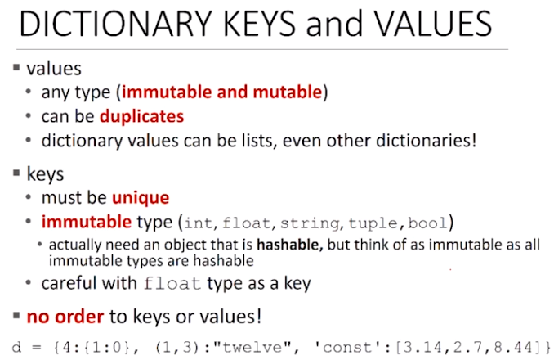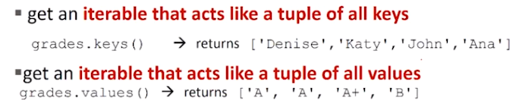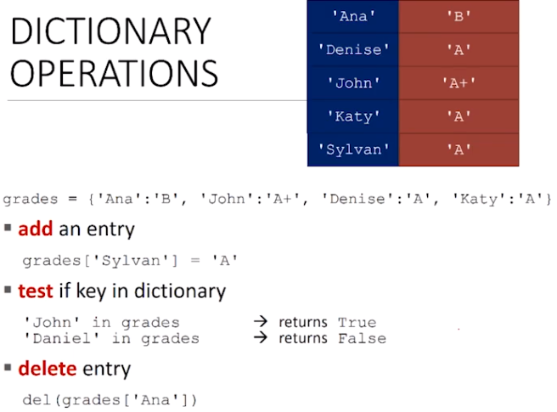

Dictionaries are mutable, both add and change entries inside of a dictionary.

The order of the dictionary depends on how things are put into the dictionary

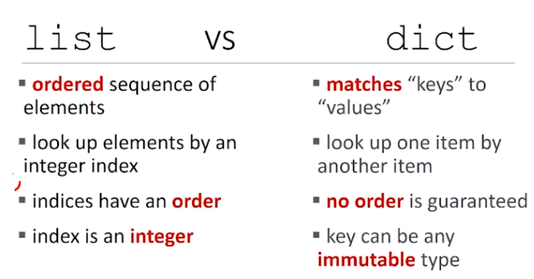

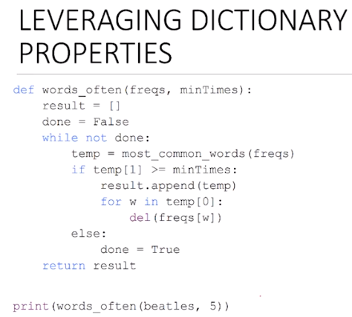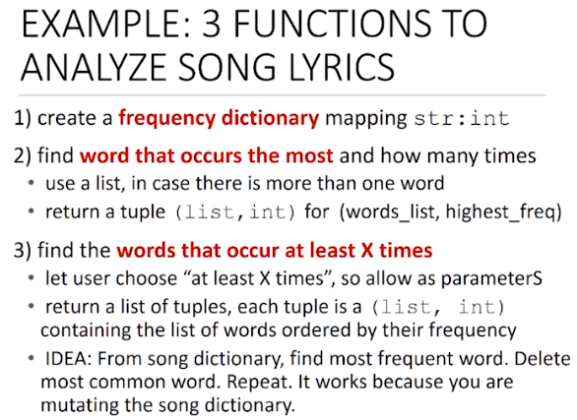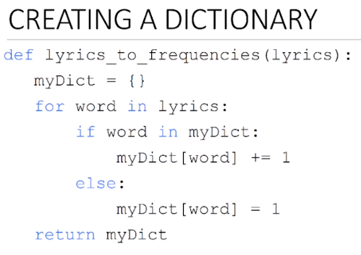

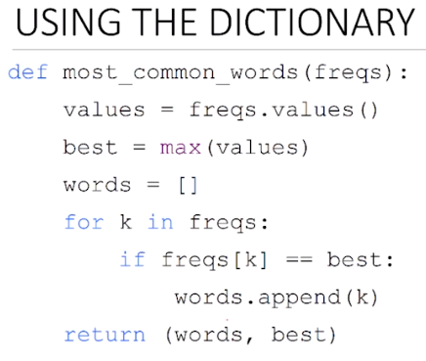

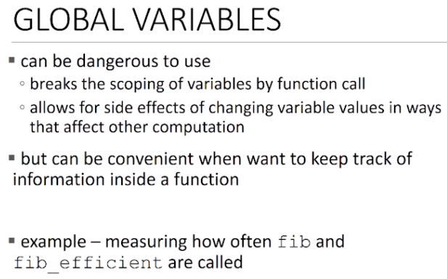 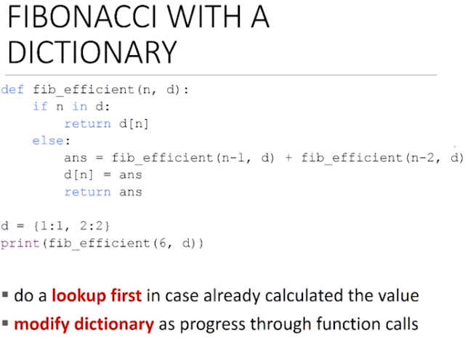

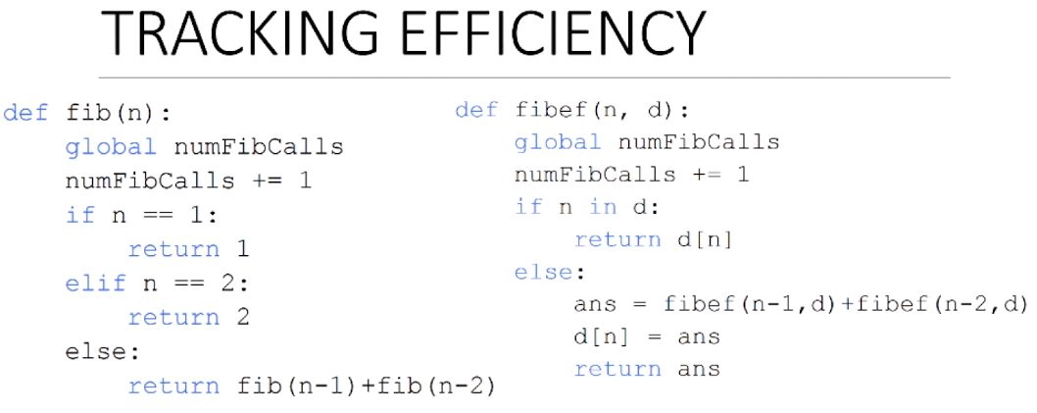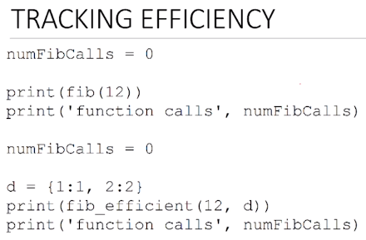

* By using the dictionary fibef requires only 57 calls in order to compute fib of 30 while fib simple requires 1.66M calls to compute the same calculation